Bishop Richard Miles, OP

Preface – Catholic American History
Cecelius Calvert received a charter from King Charles, granting him almost regal powers and ownership of all the land of the colony which he had named Maryland, in honor of the Mother of God. This land was used to attract settlers to the America.

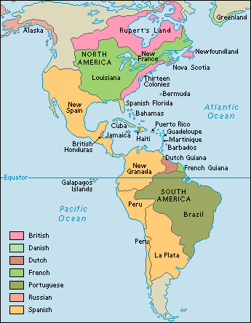
Those who would pay their own way to Maryland were granted 100 acres of land, and if they transported servants–men and women who agreed to indentured service for seven years to pay for their passage–they could obtain 100 more acres. Later, that amount was reduced to 50 acres of land, and the servants, after their term of servitude was over, would also be granted 50 acres of land.
Settlements by Nationality

After months of preparation and delays, the first colonists sailed from Cowes, Isle of Wight, England on Nov. 22, 1633, on two ships, the Ark and the Dove. The colony prospered, in spite of political and religious controversy. In England, there was continued political upheaval and religious intolerance, and that condition was reflected in Maryland. There were repeated efforts to wrest the government from Lord Baltimore. In 1649, the Maryland General Assembly passed an Act of Religious Toleration, which was remarkable because it was passed at a time when there was rampant religious intoleration, both in England and in the other American colonies.

After several abortive attempts at overthrowing the Proprietary government in Maryland, the Protestant revolution of 1689 was successful. It was fomented largely by the non-Catholic colonists of Maryland–about two-thirds of the population of Maryland at that time–who had benefited by the religious toleration policies of Lord Baltimore. (They were there because of the religious tolerance he professed)

Almost immediately after the take-over occurred, the subjugation of all Catholics began in Maryland. Justices and other public officials, even sheriffs and clerks, were replaced if they were Catholics. Arms and ammunition of most Catholics were confiscated. The very presence of any Catholic in St. Mary’s City during the session of the Protestant Associators – the group which was to constitute the ruling body of Maryland for the next two years–was forbidden.

In 1692, an Act was passed which established the Anglican Church as the official church of the colony, and all residents were taxed to support the church. Catholics were excluded from public office, from voting, or even jury duty.

In 1704, the “Act to prevent the Growth of Popery within this Province” not only forbade all works of conversion but also closed all Catholic churches and schools in the province. Most of them still clung to their Faith, however, and practiced their religion privately, in their own homes. Many baptisms and marriages were recorded in the Anglican churches, usually with a notation that they were known Catholics
These restrictions on public worship and other persecution of Catholics continued through the colonial period, which extended to the American Revolution and the Bill of Rights.

Marylanders, both Catholic and Protestant, fought valiantly in the Revolution, and the newly-independent United States used the vast western domain which the English had won in the French and Indian War and ceded to the new American nation at the end of the Revolution, to reward those who served in the Continental Army and Navy. These western lands were also available to persons other than veterans, and between 1789 and 1799, nearly 500,000 acres of undeveloped western land, most of it in what is today the States of Kentucky, Tennessee, Ohio, Indiana and Illinois, was offered as a means to promote settlement of the country’s frontier.

Many of these western migrants were Maryland Catholics. Burdened by a century of anti-Catholic bias in Maryland, they sought not only new land but, once again, religious freedom. Even before the greatest migration began in 1789, Maryland Catholics were on the move.

In 1785, a group of southern Maryland residents formed a “Catholic League of Families” and agreed to move to Kentucky as soon as they could settle their affairs in Maryland. John Carroll, Archbishop of Baltimore, promised to send a parish priest if the emigrants settled together.

Because most of these people were Catholics, this area of Kentucky is known, even today, as the Kentucky Holy Lands.

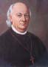
Richard Miles is one of the unsung heroes of American Catholicism, and especially of its move beyond the Appalachians. He was born on May 17th, 1791, the youngest of seven children born to a builder in Prince George's County, Maryland. The Miles family joined, five years later, a sizeable emigration of Maryland Catholics to Kentucky, and established themselves among fellow Catholics in Nelson County. The first serious explorations of the Kentucky territory by English colonists had begun around 1750, and it was found that the area was not generally inhabited by Indians, but was used primarily as a hunting ground by Indian tribes living along the tributaries north of the Ohio River and by the southern Cherokee tribes.

Relatively little attention has been paid to the relentless hostility toward the Catholics of our 13 English colonies in the period that preceded the American Revolution. Instead, historians have tended to concentrate only on the story of the expansion of the tiny Catholic community of 1785, which possessed no Bishop and hardly 25 priests, into the mighty organization we see today.
It should not be surprising that this cloud of general omission concerning Catholicism in the colonial period (1600-1775) should have settled over the Catholic milieu given the optimistic accounts written by such notable Catholic historians as John Gilmary Shea, Thomas Maynard, Theodore Roemer, and Thomas McAvoy. (1) These historians, whose works provided the foundation for Catholic school history books up until recently (when a different kind of revisionist history is replacing them), only briefly acknowledge and downplay a period of repression and persecution of Catholics.
What they have stressed is what might be called the "positive" stage of Catholic colonial history that begins in the period of the American Revolution. This period has been glossed with an unrealistic interpretation that freedom of religion was unequivocally established and the bitter, deeply-entrenched anti-Catholicism miraculously dissolved in the new atmosphere of tolerance and liberty for all. This in fact did not happen.

Roots of a bad Ecumenism
There is a myth that America was from its very beginning a country that championed freedom of religion. In fact, in the colonial period, a virulent anti-Catholicism reigned and the general hounding and harrying of Catholics was supported by legislation limiting their rights and freedom.

Cardinal James Gibbons was warned by Pope Leo XIII about Americanism
It is important for Catholics to know this in order to understand how this persecution affected the mentality of Catholics in America in its early history and generated a liberal way of behavior characterized by two different phases of accommodation to Protestantism:
First, both before and especially after the American Revolution, a general spirit of tolerance to a Protestant culture and way of life was made by some Catholics in order to be accepted in society. Such accommodation has continued into our days.
Second, to enter the realm of politics and avoid suspicions of being monarchists or “papists,” colonial American Catholics were prepared to accept the revolutionary idea of the separation of Church and State as a great good not only for this country, but for Catholic Europe as well. Both civil and religious authorities in America openly proclaimed the need to abandon supposedly archaic and “medieval positions” in face of new conditions and democratic politics.
For these reasons, some hundred years after the American Revolution, Pope Leo XIII addressed his famous letter Testem benevolentiae (January 22, 1889) to Cardinal Gibbons, accusing and condemning the general complacence with Protestantism and the adoption of naturalist premises by Catholics in the United States. He titled this censurable attitude Americanism. Americanism, therefore, is essentially a precursory religious experience of bad Ecumenism made in our country, while at the same time Modernism was growing in Europe with analogous tendencies and ideas.
A long history of anti-Catholicism
Although Catholicism was an influential factor in the French settlements of the Ohio and Mississippi valleys and later in the Spanish regions of Florida, the Southwest and California, Catholics were a decided minority in the original 13 English colonies. As we see in the first general report on the state of Catholicism by John Carroll in 1785, Catholics were a mere handful. He conservatively estimated the Catholic population in those colonies to be 25,000. Of this figure, 15,800 resided in Maryland, about 7,000 in Pennsylvania, and another 1,500 in New York. Considering that the population in the first federal census of 1790 totaled 3,939,000, the Catholic presence was less than one percent, certainly not a significant force in the original 13 British colonies. (2)
Catholics were not welcome in the original 13 colonies
After several pages dedicated to Lord Baltimore's Catholic colony in Maryland, Catholic history books have tended to begin Catholic history in the United States with that critical year for both the nation and Catholicism - 1789. For 1789 marked both the formation of the new government under the Constitution and the establishment of an organizational structure for the American Catholic Church. The former event came with the inauguration of George Washington in April, the latter with the papal appointment of His Excellency John Carroll as the first Bishop of Baltimore in November.
The history of the Catholic Church in America, however, has much deeper and less triumphant roots. Most American Catholics are aware that the spirit of New England's North American settlements was hostile to Catholicism. But few are aware of the vigor and persistence with which that spirit was cultivated throughout the entire colonial period. Few Catholics realize that in all but three of the 13 original colonies, Catholics were the subject of penal measures of one kind or another during the colonial period. In most cases, the Catholic Church had been proscribed at an early date, as in Virginia where the act of 1642 proscribing Catholics and their priests set the tone for the remainder of the colonial period.
Even in the supposedly tolerant Maryland, the tables had turned against Catholics by the 1700s. By this time the penal code against Catholics included test oaths administered to keep Catholics out of office, legislation that barred Catholics from entering certain professions (such as Law), and measures had been enacted to make them incapable of inheriting or purchasing land. By 1718 the ballot had been denied to Catholics in Maryland, following the example of the other colonies, and parents could even be fined for sending children abroad to be educated as Catholics.
In the decade before the American Revolution, most inhabitants of the English colonies would have agreed with Samuel Adams when he said (in 1768): "I did verily believe, as I do still, that much more is to be dreaded from the growth of popery in America, than from the Stamp Act, or any other acts destructive of civil rights." (3)
English hatred for the Roman Church
The civilization and culture which laid the foundations of the American colonies was English and Protestant. England's continuing 16th and 17th-century religious revolution is therefore central to an understanding of religious aspects of American colonization. Early explorers were sent out toward the end of the 15th century by a Catholic king, Henry VII, but actual settlement was delayed, and only in 1607, under James I, were permanent roots put down at Jamestown, Virginia. By then, the separation of the so-called Anglican church from Rome was an accomplished fact.
The supposed Catholic conspirators plotting to blow up the English Houses of Parliaments were publicly executed. Later, Jesuits were rounded up and killed also.
Rapid anti-Catholicism in England had been flamed by works like John Foxe's Book of Martyrs illustrating some of the nearly 300 Protestants who were burned between 1555 and 1558 under Queen Mary I. The tradition was intensified by tales of the 1605 Gunpowder Plot, when a group of Catholics would have supposedly planned to blow up King James but for the scheme’s opportune discovery and failure.
International politics were involved too. France and Spain were England's enemies, and they were Catholic. In 1570 Pope St. Pius V excommunicated Elizabeth I and declared her subjects released from their allegiance, which fanned English propaganda that Catholic subjects harbored sentiments of treason. (4)
In the 16th century, the English began their long, violent and cruel attempt to subdue the Catholics of Ireland. (5) The English were able “to resolve” any problem of conscience by convincing themselves that the Gaelic Irish Catholic Papists were an unreasonable and boorish people. Maintaining their false belief they were dealing with a culturally inferior people, the English Protestants imagined themselves absolved from all normal ethical restraints. This attitude persisted with their settlers in the American colonies. (6)
To these factors should be added the role of the Puritan sect. Its relationship with Catholics in colonial America represented the apotheosis of Protestant prejudice against Catholicism. Even though the so-called Anglican church had replaced the Church of Rome, for many Puritans that Elizabethan church still remained too tainted with Romish practices and beliefs. For various reasons, those Puritans left their homeland to found new colonies in North America. A major Puritan exodus to New England began in 1630, and within a decade close to 20,000 men and women had migrated to settlements in Massachusetts and Connecticut. (7) They were principal contributors to a virulent hatred of Catholicism in the American colonies.
The penal age: 1645-1763
Evidence of this anti-Catholic attitude can be found in laws passed by colonial legislatures, sermons preached by colonial ministers, and various books and pamphlets published in the colonies or imported from England. (8)
By his dress, manner and spirit, the Puritan was an antithesis of the Catholic gentleman of the age
For example, even though no Catholic was known to have lived in Massachusetts Bay in the first 20 years or more of the colony's life, this did not deter the Puritan government from enacting an anti-priest law in May of 1647, which threatened with death "all and every Jesuit, seminary priest, missionary or other spiritual or ecclesiastical person made or ordained by any authority, power or jurisdiction, derived, challenged or pretended, from the Pope or See of Rome." (9)
When Georgia, the thirteenth colony, was brought into being in 1732 by a charter granted by King George II, its guarantee of religious freedom followed the fixed pattern: full religious freedom was promised to all future settlers of the colony “except papists,” that is Catholics. (10)
Even Rhode Island, famous for its supposed policy of religious toleration, inserted an anti-Catholic statute imposing civil restrictions on Catholics in the colony's first published code of laws in 1719. Not until 1783 was the act revoked. (11)
To have an idea of how this prejudice against Roman Catholics was impressed even among the young, consider these “John Rogers Verses” from the New England Primer: “Abhor that arrant whore of Rome and all her blasphemies; Drink not of her cursed cup; Obey not her decrees." This age of penal restriction against Catholics in the colonies lasted until after the American Revolution.
Someone recalling a lesson from his Catholic history classes might pose the objection: But what about the exceptions to this rule, that is, the three colonial states of Maryland, New York, and Pennsylvania, where tolerance for Catholics existed in the colonial period? Once again, this impression comes from a very optimistic and liberal writing of History rather than the concrete reality.
Catholicism in Maryland
The "Maryland Experiment" began when Charles I issued a generous charter to a prominent Catholic convert from Anglicanism, Lord Cecil Calvert, for the American colony of Maryland. In the new colony, religious tolerance for all so-called Christians was preserved by Calvert until 1654. In that year, Puritans from Virginia succeeded in overthrowing Calvert's rule, although Calvert regained control four years later. The last major political uprising took place in 1689, when the ‘Glorious Revolution” of William and Mary ignited a new anti-Catholic revolt in Maryland, and the rule of the next Lord Baltimore, Charles Calvert, was overthrown.
After the government of Lord Charles Calvert was overthrown in 1689, strong anti-Catholic politics were installed
Therefore, in 1692 Maryland's famous Religious Toleration Act officially ended, and the Maryland Assembly established the so-called Church of England as the official State religion supported by tax levies. Restrictions were imposed on Catholics for public worship, and priests could be prosecuted for saying Mass. Although Catholics generally maintained their social status, they were denied the right to vote or otherwise participate in the government of the colony their ancestors had founded. (12) This barebones history is the real story of the famous religious liberty of colonial Maryland.
The Religious Toleration Law of 1649 establishing toleration for all religions in early Maryland has generally been interpreted as resulting from the fact that Cecil Calvert was a Roman Catholic. Catholic American histories commonly presented the foundation of Maryland as motivated by Calvert's burning desire to establish a haven for persecuted English Catholics. On the other side are Protestant interpretations that present Calvert as a bold opportunist driven by the basest pecuniary motives. (13)
More recent works have provided a much more coherent analysis of the psychology behind the religious toleration that Calvert granted. That is, Calvert was only following a long-standing trend of English Catholics, who tended to ask only for freedom to worship privately as they pleased and to be as inoffensive to Protestants as possible.
A directive of the first Lord Proprietor in 1633 stipulated, for example, that Catholics should “suffer no scandal nor offence” to be given any of the Protestants, that they practice all acts of the Roman Catholic Religion as privately as possible, and that they remain silent during public discourses about Religion. (15) In fact, in the early years of the Maryland colony the only prosecutions for religious offenses involved Catholics who had interfered with Protestants concerning their religion.
As a pragmatic realist, Calvert understood that he had to be tolerant about religion in order for his colony, which was never Catholic in its majority, to be successful. It was this conciliatory and compromising attitude the Calverts transplanted to colonial Maryland in the New World. Further, the Calverts put into practice that separation of Church and State about which other English Catholics had only theorized.
Catholicism in New York
Neither the Dutch nor English were pleased when the Duke of York converted to Roman Catholicism in 1672. His appointment of Irish-born Catholic Colonel Thomas Dongan as governor of the colony of New York was followed by the passage of a charter of liberties and privileges for Catholics. But the two-edged sword of Dutch/ English prejudice against the "Romanists" would soon re-emerge from the scabbard in which it had briefly rested.
Jacob Leisler fanned anti-Rome fears to take power in New York and then issued arrests for all "papists"
After the “Glorious Revolution” of 1688, the virulently anti-Catholic Jacob Leisler spread rumors of “papist” plots and false stories of an impending French and Indian attack upon the English colonies, in which the New York colonial Catholics were said to be aligned with their French co-religionists. Leisler assumed the title of commander-in-chief, and by the end of the year he had overthrown Dongan and taken over the post of lieutenant governor of the colony as well. His government issued orders for the arrest of all reputed “papists,” abolished the franchise for Catholics, and suspended all Catholic office-holders. (16) The government after 1688 was so hostile to Catholics, noted Catholic historian John Ellis, "that it is doubtful if any remained in New York." (17)
That very fact made all the more incongruous the severity of measures that continued to be taken against Catholics, which included the draconian law of 1700 prescribing perpetual imprisonment of Jesuits and “popish” messengers. This strong anti-Catholic prejudice persisted even into the federal period. When New York framed its constitution in 1777, it allowed toleration for all religions, but Catholics were denied full citizenship. This law was not repealed until 1806. (18)
The myth of religious toleration of Catholics in New York relies concretely, therefore, on that brief 16-year period from 1672 to 1688 when a Catholic was governor of the colony.
Catholicism in Pennsylvania
Due to the broad tolerance that informed William Penn's Quaker settlements, the story of Catholics in Pennsylvania is the most positive of any of the original 13 colonies. William Penn's stance on religious toleration provided a measured freedom to Catholics in Pennsylvania. The 1701 framework of government, under which Pennsylvania would be governed until the Revolution, included a declaration of liberty of conscience to all who believed in God. Yet a contradiction between Penn's advocacy of liberty of conscience and his growing concern about the growth of one religion – Roman Catholicism – eventually bore sad fruit.
Penn imposed restrictions on the rights of Catholics
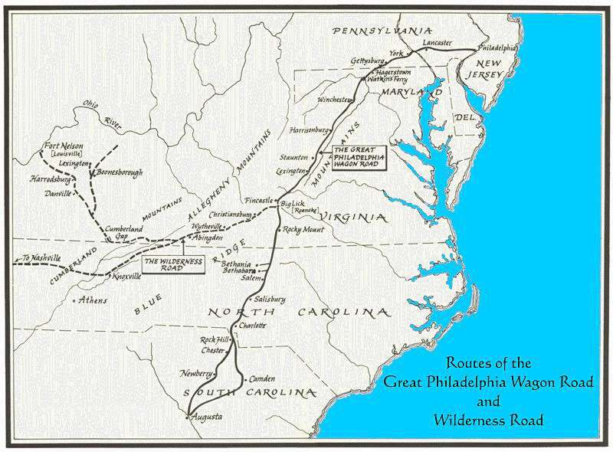
To replace the liberal statutes that provided almost unrestricted liberty of conscience and toleration for those who believed in Christ, officials were required to fulfill the religious qualifications stated in the 1689 Toleration Act, which allowed Dissenters their own places of worship, teachers and preachers, subject to acceptance of certain oaths of allegiance. The act did not apply to Catholics, who were considered potentially dangerous since they were loyal to the Pope, a foreign power. Catholics were thereby effectively barred from public office. (19)
Despite the more restrictive government imposed by Penn after 1700, Catholics were attracted to Pennsylvania, especially after the penal age began in neighboring Maryland. Nonetheless, the Catholic immigrants to Pennsylvania were relatively few in number compared to the Protestants emigrating from the German Palatinate and Northern Ireland. A census taken in 1757 placed the total number of Catholics in Pennsylvania at 1,365. In a colony estimated to have between 200,000 and 300,000 inhabitants, the opposition against the few Catholics living among the Pennsylvania colonists is testimony to an historic prejudice, to say the least. (20)
Even in face of incessant rumors and several crises (e.g. the so-called “popish plot” of 1756), no extreme measures were taken and no laws were enacted against Catholics. A good measure of the prosperity of the Church in 1763 could be attributed to the Jesuit farms located at St. Paul's Mission in Goshehoppen (500 acres) and Saint Francis Regis Mission at Conewago (120 acres), which contributed substantially to the support of the missionary undertakings of the Church. (21) The history of the Jesuits has been called that of the nascent Catholic Church in the colonies, since no other organized body of Catholic clergy, secular or regular, appeared on the ground till more than a decade after the Revolution. (22)
Relaxation of anti-Catholicism in the revolutionary era
This phase of strong, blatant persecution of Catholicism came to a close during the revolutionary era (1763-1820). For various reasons, the outbreak of hostilities and the winning of independence forced Protestant Americans to at least officially temper their hostility toward Catholicism. With the relaxation of penal measures against them, Catholics breathed a great sigh of relief, a normal and legitimate reaction.
However, instead of maintaining a Catholic behavior consistent with the purity of their Holy Faith, many of them adopted a practical way of life that effectively ignored or downplayed the points of Catholic doctrine which Protestantism attacked. They also closed their eyes to the evil of the Protestant heresy and its mentality. Such an attitude is explained by the natural desire to achieve social and economic success; it is, nonetheless a shameless attitude with regard to the glory of God and the doctrine that the Catholic Church is the only true religion.
As this liberal Catholic attitude continued and intensified, it generated a kind of fellowship that developed among Catholics with Protestants as such. And so, an early brand of an experimental bad Ecumenism was established, where the doctrinal opposition between the two religions was undervalued and the emotional satisfaction of being accepted as Catholics in a predominantly Protestant society was overestimated.
These psychological factors help to explain the first phase of the establishment among our Catholics ancestors of that heresy which Pope Leo XIII called Americanism.

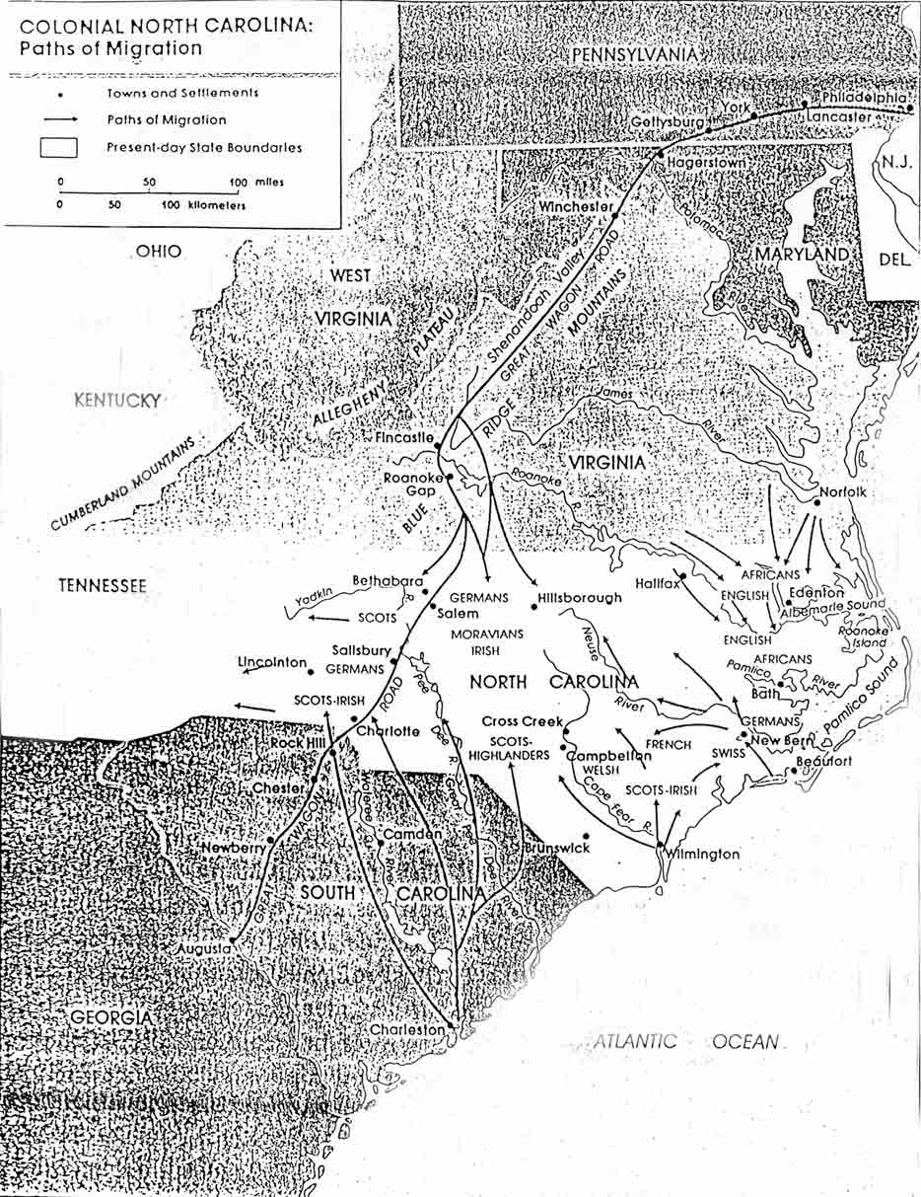
As Edward Fenwick pondered the options for his college and community in Maryland, Bishop Carroll's totally different plan was in his own mind a fait accompli. It was already known in far–off Kentucky, and confirmed by a letter of Stephen T. Badin, proto–priest in the United States and missionary near Bardstown, who wrote to Bishop Carroll, "I am happy to hear of the Dominicans coming shortly to this state. . . " (16) What a surprise this would be for Fenwick! Carroll had already decided to send the Dominicans to Kentucky without first proposing the plan to them.
Bishop Carroll was aware of conditions, of which the newly–arrived Dominicans were ignorant, both in Maryland and in Kentucky, the western frontier of his diocese. For one thing, the flourishing state of Maryland at this time already could boast of one college, Georgetown Academy, established by Carroll himself. Carroll was also fully knowledgeable about the settlers who had been moving westward from Maryland, Fenwick's native state, into Kentucky for about two decades. In the year 1785, a "League" of sixty families had began their migration from St. Mary's County in southern Maryland to the land near Pottinger's Creek, Kentucky. Twenty-five families left in 1785; the rest followed at their convenience.(17)
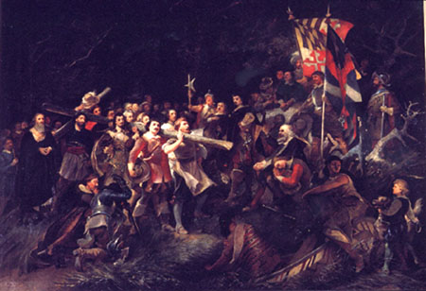
The exact reason the Marylanders left home probably differed for each family, but in general there were economic and religious reasons. Practically all the families in the "league" were Catholic. Religious difficulties in Maryland had declined considerably since mid-eighteenth century, but suspicions of antiCatholic bigotry on the part of local magistrates remained. However, economic conditions figured more prominently in their move to the west. The good soil for growing tobacco in Maryland was exhausted and exaggerated accounts of rich, fertile soil in Kentucky lured landowners to the frontier. Under the Articles of Confederation the people of Maryland and other colonies suffered from trade barriers and devaluation of currency. Among the most prominent names in Kentucky's history were those who came with the "League." Some familiar names. included Hayden, Hagan, Miles, Spalding, Bowles, Nally, Boone, Mudd, Mattingly and Edelin. (18) They settled in what today is considered the Holy Land of Kentucky - Nelson, Washington & Marion Cos
In the early spring of 1805, at the first meeting between Carroll and the Dominican friars Fenwick and Angier, the bishop revealed his plan that they turn their attention to Kentucky. Despite their surprise and disappointment, the two college instructors, cherishing their apostolic vocation more than their original plan, agreed to explore the possibilities. In early May of 1805, Edward Fenwick, accompanied by his brother–in–law, Nicholas Young, journeyed to Kentucky to consider the prospects of a successful Dominican establishment there.
They were received cordially by an effusive Stephen Badin who wrote Carroll,
I have the happiness this day of enjoying the company of Rev. Mr. Fenwick which you had announced in former letters, intimating as soon as he arrived in America that . . . you would engage him to turn his views toward our desolate congregations. I hope you will grant me the favour or leave of transferring to that religious order (the Order of Preachers or Dominicans) the Ecclesiastical property now in my hands, to which I have added 220 acres of my own land.(19)
The Dominicans were later to discover that Badin's initial enthusiasm and generosity about church properties could not be taken too literally.
This warm reception in Kentucky encouraged Fenwick to write to Luke Concanen, his Roman brother and sponsor:
I have mentioned twice to you the advice and encouragement Bishop Carroll gives to fix our establishment in the Province of Kentucky which I have accepted of conditionally; i. e. , if our General approves of it, and my confreres arrive and unite with me in opinion. (20)
Fenwick had much to learn yet of the impulsiveness of Badin and the rapid change in mood the French missionary was often to demonstrate. Fenwick and his brother-in-law Young returned to Maryland. There he reviewed all that he had seen in Kentucky as he anticipated the arrival of Wilson and Tuite from Belgium.

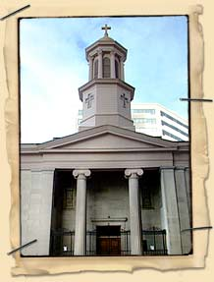
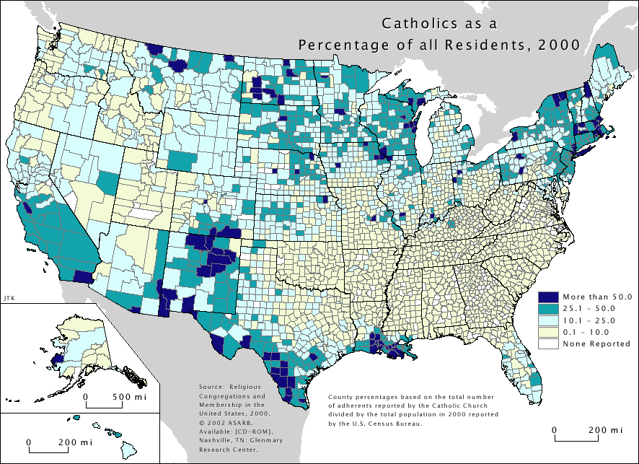
There they prospered, and, from all accounts, lived quite happily. The Catholic community there grew, but not without the problems endemic to any frontier: a great lack of clergy and churches. This problem was greatly alleviated by the arrival, in 1805, of three Dominicans, who established churches and the first Catholic school west of the Appalachians. They also opened the second oldest monastary in the country, St. Rose's, near Bardstown in 1806.
Miles entered the Dominicans' school at 15. The record is unclear as to when he took the habit, but it was apparently in 1809. It at his investiture that he took the name Pius, after St. Pius V. After completing his studies and receiving ordination, he stayed on as a teacher at the college, where he distinguished himself. Thereafter he worked as a missionary in Ohio (Kentucky, Ohio, Tennessee, Indiana, and parts of Illinois had been split from the Diocese of Baltimore and formed into the Diocese of Bardstown in 1808 - a town that has surely lost some of its former glory). In 1833 he was elevated to superior of St. Rose's. In April of 1837, Miles was elected provincial for the Dominican Province of St. Joseph (including at that point the entire eastern United States) on the first ballot.
During this time, the population of Tennessee was growing, and the number of Catholics grew as well. Most of the laborers and craftsmen needed to build roads, bridges, and cities were at that time Irish, and they were in very high demand in the state. However, they were very reluctant to come to Tennessee, much less stay there for any period, as there was not in the entire state a priest or church, and the Catholic workers were afraid of suffering a mortal wound in their dangerous work and dying without the benefit of the sacraments. But such was the state in which all of Tennessee's Catholics, few and far dispersed as they might have been, lived. In fact, developers and would-be city elders attributed the slow growth in much of the state largely to the lack of Catholic institutions, such an impediment did it present to the importation of the necessary labor. Such were the spiritual deprivations that they lived under that in some places, such as Knoxville, which had many traditionally Catholic families, the faith died out completely for want of pastoral care. Such were the straits of the Church in Tennessee, and so inadequate were the resources of Bardstown to rectify them, that in 1837 it was recommended that the state be made its own episcopal see, and that Fr. Miles be nominated its head.
Pope Gregory XVI acquiesced to this request on July 28th, 1837, by act of the Brief Universi Dominici Gregis, and appointed Miles as Nashville's first bishop through the bull Apostoluatus Officium. Miles was consecrated in a well-documented ceremony in Bardstown on September 16th, 1838. He was presented the task of forging a diocese out of a state that was largely wilderness, in which there lived an indeterminate number of Catholics, most of whom had not seen a priest for years, if ever.
The reality turned out to be almost as disinheartening as the prediction. The state at this point had one ramshackle "church," a broken down building that, although bearing the name of the Most Holy Rosary, was in such disrepair that the priest who was ministering intermittantly to Nashville held mass elsewhere by this point. (The church stood on what is now Capital Hill, and had been built during the efforts to bridge the Cumberland River - the Irish workers had been brought in, seen there was neither church nor priest, and had promptly sat down and refused to work until the situation was rectified. So eager was the populace to have their bridge that the land was actually donated to the Church by a local Mason!) Miles arrived in Nashville in the Christmas season of 1838, and set out to see what was the nature of the land that had been entrusted to his care. Traversing the state, he discovered approximately 300 Catholics -- including one 80 year old man who, Simeon-like, had waited 30 years to receive the Blessed Sacrament. He renovated the Cathedral of the Holy Rosary, and arranged for churches to be erected throughout the state, and for priests to visit them regularly.
In 1847, Bishop Miles, having submitted to the pressure of the state to sell the ground the Cathedral sat on for the new capital, consecrated the new Cathedral, The Seven Sorrows of Mary, located just down the road from the old site. The new church was designed by William Strickland, the same architect who built (and is buried in) the Tennessee capital that supplanted the original church. (The architectural resemblance shows.) At the time, it was the largest structure west of the Appalachians with no internal support columns. Incidently, the industrious bishop saved the materials from Holy Rosary and later used them to build a church for Nashville's German Catholics. In the late 1850's, Miles travelled to Memphis to consecrate St. Peter's. This impressive Gothic structure was the city's first Catholic church (mass having before been said in a house next door to the site), and still stands today as almost indisputably its most beautiful structure of any kind or denomination. He built schools, a seminary, and a convent in Nashville -- a legacy carried on in the continued presence of the Domincan convent and college.
On February 21st, 1860, when Bishop Miles died, he left Tennessee much different than when he arrived. What had been an empty land devoid of the faith now contained 13 clergymen, 14 churches, 6 chapels, thirty "stations," a seminary, three communities of sisters, an academy for girls, 9 parochial schools, an orphanage, and 12,000 Catholics. He surely bears great responsibility for the existence of the Church in Tennessee, and the vibrance which it has come to have.

Richard Pius Miles, O.P. (May 17, 1791—February 17, 1860) was the first Roman Catholic Bishop of Nashville (1838-1860). Miles was born in Prince George's County, Maryland, and moved to Kentucky with his parents at age 5. After joining the Dominican Order in October 1806, he was ordained a priest on September 21, 1816. He then worked as a missionary in Ohio and Kentucky for 22 years, also founding a community of Dominican nuns and a school under the Sisters of Charity. On July 28, 1837, Miles was appointed the first Bishop of the newly-erected Diocese of Nashville, Tennessee, by Pope Gregory XVI. He received his episcopal consecration on September 16, 1838 from Bishop Joseph Rosati, C.M. , with Bishops Simon Bruté and Guy Ignatius Chabrat, P.S.S. , serving as co-consecrators. During his tenure, he dedicated a cathedral in 1848, ordained the first priest in Tennessee, and established a seminary and a hospital. Miles later died at age 68. At the time of his death, the diocese comprised 12,000 Catholics, 13 priests, 14 churches, 6 chapels, and 13 missions

Miles was buried beneath the altar of St. Mary's. In 1972, he was exhumed, and found to be incorrupt. He now lies in a chapel in the rear of this first of his churches. May his intercession continue to aid and guide those of us who owe our ecclesiastical institutions, and, in many ways, our faith, to his work and prayer. Bishop Richard Pius Miles Tomb is located inside St. Mary of the Seven Sorrows Catholic Church, at 330 Fifth Avenue North, Nashville. St. Mary’s is the oldest standing church in downtown Nashville. Dedicated as the first Catholic Cathedral in Nashville on October 31, 1847. In 1914, a new cathedral was built on West End Avenue and was named Cathedral of the Incarnation. St. Mary of the Seven Sorrows became a parish church, now referred to as "The Old Cathedral
1969, his body was exhumed and found to be perfectly preserved after 109 years of burial. Today his body lies at rest in an African teakwood box in the rear corner of St. Mary of the Seven Sorrows Churchin Nashville, TN USA.

